Glossary
Term | Definition
Playwright | A browser automation framework used to test web applications.
Pytest | A Python testing framework used to create and execute test cases.
Fixture | A reusable setup provided to a test.
Assertion | A check that compares the actual result with the expected result.
Allure | A test reporting framework that presents automated test results in a structured report.
Requirements File | A file containing Python package dependencies required by a project.

Technical Learning Report: Day 5
Date: October 5, 2026
Intern Name: Shekhar Singh Rawal
Subject: Playwright Pytest with Allure & Week 5 Revision

1. Objective
The objective of Week 5 Day 5 was to continue practical work with Playwright, Pytest, and Allure reporting and revise the major topics covered throughout Week 5. The practical work focused on creating automated test cases for the DemoQA Login and Registration modules, using Allure metadata to organize the tests, and maintaining Python dependencies using requirements.txt. The day also included revision of Python OOP, Git branches and pull requests, Allure reporting, test metrics/KPIs, and Python logging.

2. Technical Breakdown

2.1 Playwright with Pytest
Playwright was used with Pytest to automate browser-based test cases.
The basic structure used was:
def test_example(page: Page):
page.goto("https://demoqa.com/login")
Here:
- page represents the browser page.
- page.goto() navigates to the application.
- Playwright locators are used to interact with UI elements.
- Pytest identifies functions beginning with test_ as test cases.

2.2 Allure Integration
Allure metadata was added to the Playwright tests to make the automated tests easier to organize and understand.
The tests used decorators such as:
@allure.title(...)
@allure.description(...)
@allure.feature(...)
@allure.story(...)
@allure.severity(...)
For example:
@allure.title("User login with valid username and password")
@allure.description("Verify that a registered user can successfully log in...")
@allure.feature("Login")
@allure.story("Valid Login")
@allure.severity(allure.severity_level.CRITICAL)
This connects the automated test with its functionality, scenario, description, and importance.

3. Practical Work – Registration Module
The DemoQA Registration module was automated using Playwright and Pytest.
The registration flow included: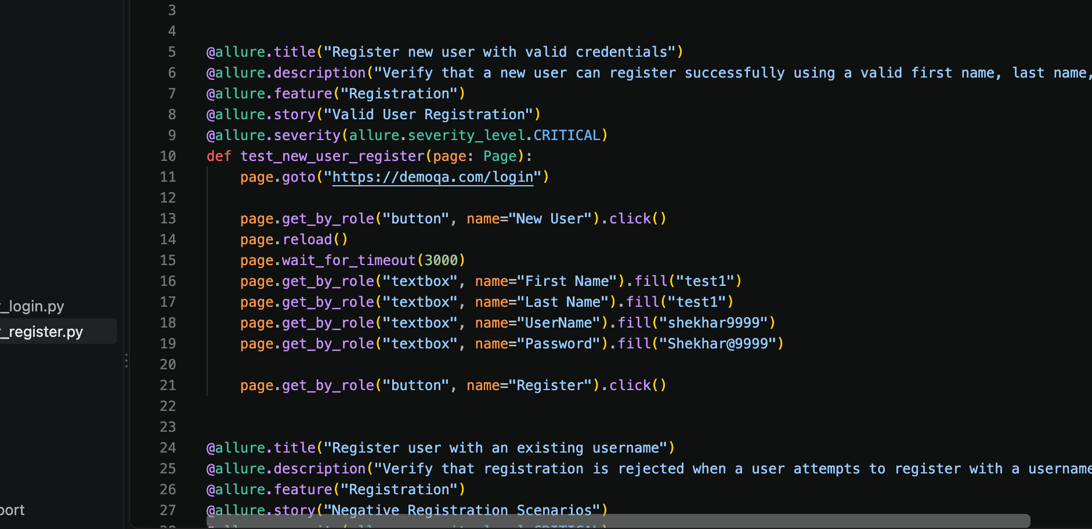
Open Login Page
↓
Click New User
↓
Enter Registration Details
↓
Click Register
↓
Verify Expected Behaviour

Registration Test Cases
Test Case | Scenario | Allure Feature | Story | Severity
1 | Register new user with valid credentials | Registration | Valid User Registration | Critical
2 | Register using an existing username | Registration | Negative Registration Scenarios | Critical
3 | Register using an invalid password | Registration | Negative Registration Scenarios | Normal

Example
For the valid registration scenario, the test entered:
page.get_by_role("textbox", name="First Name").fill("test1")
page.get_by_role("textbox", name="Last Name").fill("test1")
page.get_by_role("textbox", name="UserName").fill("shekhar9999")
page.get_by_role("textbox", name="Password").fill("Shekhar@9999")
The Register button was then clicked:
page.get_by_role("button", name="Register").click()

4. Practical Work – Login Module
The DemoQA Login module was also automated using Playwright and Pytest.
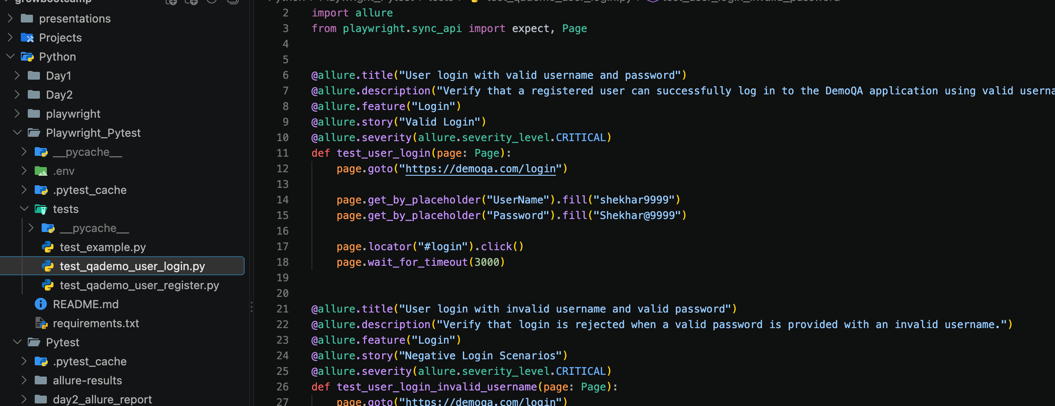
The login scenarios covered both positive and negative testing.

Login Test Cases
Test Case | Scenario | Allure Feature | Story | Severity
1 | Login with valid username and password | Login | Valid Login | Critical
2 | Login with invalid username | Login | Negative Login Scenarios | Critical
3 | Login with valid username and invalid password | Login | Negative Login Scenarios | Critical
4 | Login with empty username and password | Login | Negative Login Scenarios | Normal

Valid Login
The test navigated to the login page and entered valid credentials:
page.get_by_placeholder("UserName").fill("shekhar9999")
page.get_by_placeholder("Password").fill("Shekhar@9999")
page.locator("#login").click()

Invalid Username
The negative scenario used an invalid username and checked the displayed error:
expect(page.locator("#name")).to_contain_text("Invalid username")

Invalid Password
The test checked the expected invalid-login message:
expect(page.locator("#name")).to_contain_text(
"Invalid username or password!"
)

Empty Fields
The test submitted the login form without credentials and checked that the fields received the invalid CSS class:
expect(page.locator("#userName")).to_have_class(
re.compile(r"\bis-invalid\b")
)
expect(page.locator("#password")).to_have_class(
re.compile(r"\bis-invalid\b")
)

5. Locator Strategies Practiced
Different Playwright locator strategies were used while creating the test cases.
Locator | Example | Purpose
Role | get_by_role("button", name="New User") | Locate elements using their accessible role/name
Textbox | get_by_role("textbox", name="First Name") | Locate input fields
Placeholder | get_by_placeholder("UserName") | Locate inputs using placeholder text
CSS Selector | locator("#login") | Locate elements using CSS selectors
ID Selector | locator("#name") | Locate an element using its ID
Using meaningful locators makes automated tests easier to understand and maintain.

6. Assertions in Playwright
Assertions were used to verify expected application behaviour.
Examples included:
expect(page.locator("#name")).to_contain_text("User exists")
and:
expect(page.locator("#name")).to_contain_text(
"Passwords must have"
)
Assertions allow the automation script to determine whether the observed result matches the expected result.

7. Pytest and Allure Test Organization
The tests were organized using Allure metadata.
The structure was:
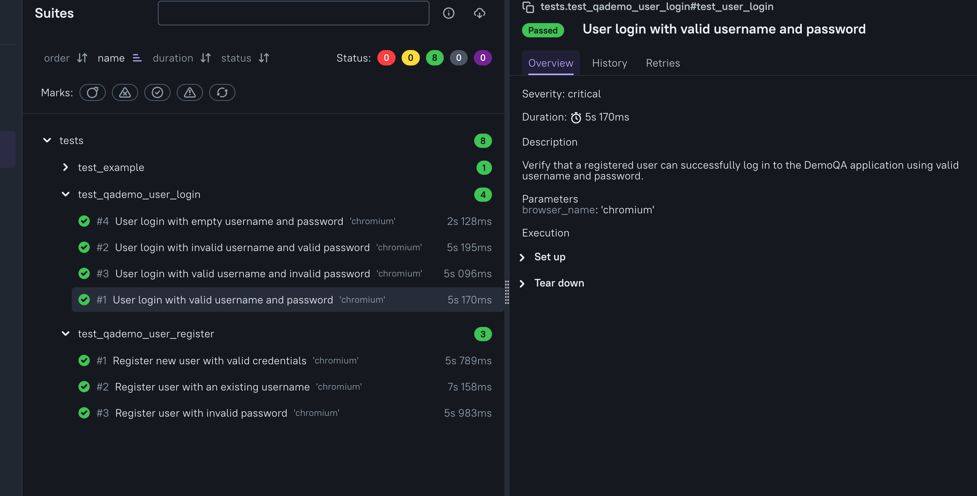
For example:
Login
├── Valid Login
│ └── User login with valid username and password
│
└── Negative Login Scenarios
├── Invalid username
├── Invalid password
└── Empty fields
This makes the test suite easier to understand from a functional perspective.

8. Python Package Management
Python package management was also covered during the practical work.
The project dependencies can be captured using:
pip freeze > requirements.txt
This generates a requirements.txt file containing the installed Python packages and their versions.
The file can later be used to install the same dependencies in another environment:
pip install -r requirements.txt
This is useful when sharing an automation project with other team members or setting up the project on another machine.

9. Week 5 Revision
The second major activity of Day 5 was revision of the important topics covered during Week 5.

Python OOP
Revised:
- Classes and objects
- Inheritance
- Polymorphism
- Encapsulation
- Abstraction
- Exception handling
- Reusable automation structures
These concepts are useful for creating maintainable automation code.

Git Branches and Pull Requests
Revised:
- Git branches
- Creating and switching branches
- Making changes in a separate branch
- Merging branches
- Pull Requests
- Code review
- Merge conflicts
The main purpose of branches is to allow team members to work independently without directly modifying the main branch.

Allure Reporting
Revised:
- Feature
- Story
- Title
- Description
- Severity
- Behaviors
- Suites
- Trends
Allure was also applied practically to the DemoQA Playwright tests.

Test Metrics and KPIs
Revised:
- Pass Rate
- Defect Density
- Test Coverage
- Test Trends
- Release-readiness interpretation
These metrics help QA teams monitor testing progress and product quality.

Python Logging
Revised:
- Python logging module
- DEBUG
- INFO
- WARNING
- ERROR
- CRITICAL
- Log files
- Using logs for root-cause analysis

10. Practical Test Coverage
The practical work covered both positive and negative scenarios.
DemoQA
│
├── Registration
│ ├── Valid registration
│ ├── Existing username
│ └── Invalid password
│
└── Login
├── Valid credentials
├── Invalid username
├── Invalid password
└── Empty fields
A total of 7 Playwright/Pytest test cases were written across the Registration and Login modules.
The provided code demonstrates the test implementation and assertions; execution pass/fail results were not included in the provided material.

11. Key Findings & Best Practices
- Playwright can automate complete browser interactions using Python and Pytest.
- Positive and negative scenarios should both be included in automation.
- Meaningful locators improve test readability and maintainability.
- Assertions are required to verify whether the actual result matches expectations.
- Allure metadata makes automated tests easier to organize and understand.
- requirements.txt helps maintain consistent Python dependencies across environments.
- OOP concepts can help create reusable and maintainable automation frameworks.
- Git branches and Pull Requests support collaborative automation development.
- Metrics and logging help QA teams monitor execution and investigate failures.

12. Conclusion
Week 5 Day 5 combined practical automation with revision of the major Week 5 topics. Playwright and Pytest were used to create 7 automated test cases for the DemoQA Login and Registration modules, including positive and negative scenarios. Allure metadata was used to organize the tests, while Python dependency management was practiced using requirements.txt. The day also revised Python OOP, Git branching and Pull Requests, Allure reporting, test KPIs, metrics, and Python logging, consolidating the major automation and test-monitoring concepts covered during Week 5.

